Muzapp

an NFT marketplace for musical artwork

Project Proposal

## 

Supervisor

Asif Khalid Qureshi

Submitted by

Abrar Ul Abdin

CS191007

Poorab Gangwani

CS191092

**Faculty of Computer Sciences**

DA SUFFA University, Karachi.

7-7-2023

Table of Contents

1. Introduction 3

2. Objective 3

3. Problem Description 3

4. Methodology 3

5. Project Scope 3

6. Feasibility Study 3

7. Solution Application Areas 3

8. Tools/Technology 4

9. Expertise of the Team Members 4

10. Milestones 4

11. Project Schedule 4

12. Work Breakdown Structure 4

13. Business Model Map 4

14. Business Model Canvas 5

15. References 5

# **Introduction**

# A revolutionary NFT marketplace for musical creativity, MUZAPP is a decentralized application (DApp) which offers a platform where musicians and music collectors may display, market, and exchange their non-fungible tokens (NFTs) created from digital music. MUZAPP offers transparent ownership, copyright protection, and safe transactions throughout the music community by utilizing blockchain technology.

Incorporating elements like **fixed price sales**, **pay-per-use**, **auctions**, **free musical publishing and listening**, **open offer and exchange-based** sales etc. The platform creates a complete ecosystem for musical artists and music lovers

# **2. Objective**

# To design and develop a musical NFT marketplace where musical artists can publish, promote, monetize and control their musical work independently without having to depend on 3rd party intermediaries like music companies of streaming services

# **3. Problem Description**

# In the music industry, there is a growing need for a dedicated marketplace that caters to the unique requirements of musicians, artists, and collectors. Moreover, musicians have to endure severe conditions in the real world of music where many are strong armed into unfair deals which also includes lack of creative control and copyright over their work. They also suffer great financial woes by being afforded relatively small fragments of the overall revenue generated by their music while the appreciable remainder sum is taken by publishers, distributors etc.

# a lot of a musician’s misfortunes persist greatly in the music streaming world as well where many streaming services stress for exclusivity on the content they stream thus greatly constraining the level of exposure and recognition a musician’s work gets and by extension amount of revenue possible.

# **4. Methodology**

# MUZAPP will leverage permission less public Block Chain technology to ensure transparent ownership, secure transactions, and copyright protection for music NFTs and further combining this aspect with its ability to mint NFTs for musical artwork, musicians of any standing and status will be given the platform to have their music published and admired by a large populace for meagre costs. Through MUZAPP, musicians can not only publish their music but retain full ownership and control over it in terms of its management and monetization. To further aid subscribed musical artists in acquiring as much financial gain from their music, MUZAPP will maintain low transaction fees through implementation in polygon-based chains while also soliciting comparatively low service fees for transactions. MUZAPP will, at low cost, facilitate musicians with different options for strong remuneration which includes auctioning, fixed price sales, pay-per-use etc.

# **5. Project Scope**

# Wallet-based registration

* **Music Mint** module for musical entities to mint NFTs of their musical work along with providing personally identifiable and descriptive information
* Monitoring and recording of customer musical preferences and automatic suggestions
* **Profile module** for musical entities
* **Past transactions module** where users can view the musical content they previously purchased, sold or paid for use.
* **Rented module** where users can view all the pay-per-use NFTs they have access to for a fixed period of time
* **Your Collection module** where musical entities can view all the musical NFTs they own in their collection
* **NFT Auction module** where musicians can take NFTs in there collection and set them up for an English auction by providing starting bid amount, auction closing date, auction accessibility (private or public) and provide their selling pitch
* **Fixed Price Sale form** where musical entities can set a fixed price for their music and declare it for sale of FCFS (first-come-first-serve) basis
* **Pay-Per-Use form** where musical entities can set pay-per-use model on their NFTs and set the amount per use of NFT.
* **Offer Solicitation module** where musical entities can solicit offers on their work and choose to sell to the most enticing one. Musical entities can specify the minimum price for the music while also being amenable to exchanges of equal value in the form of NFTs or any other tokens or coins
* **NFT Offers module** where user can view all the available musical content that is up for fixed price sale, auction, open offers, pay-per-use etc.

**Assumptions:**

- The assumption is made that there is a sufficient user base and demand for music NFTs within the target market.

- The assumption is made that artists and collectors will embrace the concept of NFTs and the benefits they offer in terms of ownership, authenticity, and monetization of their music creations.

# **6. Feasibility Study**

1. **Risks involved:**

* **Team-based risks**

1. Team member falls ill or becomes indisposed, possibly resulting in unaffordable delays in their work

**Solution** = approach and assign (in advance) colleagues who have been kept well informed of the project and also possess necessary block chain expertise as backups to help in performance of tasks that were to be performed by the indisposed team members. Also maintain ample buffer time for tasks to make sure unexpected delays do not inflict much damage on the schedule

1. Misinterpretation among team members, causing abortive results in development, design or research

**Solution** = Daily meetings among team members and review of progress in order to speedily detect faulty execution of In-Progress tasks and remedy them. Also upload tasks on JIRA software for team members with helpful links attached to help guide in the right direction

1. Lack of sufficient comprehension of the concepts utilized for the development and completion of the project

**Solution =** accommodation of relevant articles, video tutorials and consultation from supervisor at different points in the project to help in effective grasping of concepts currently utilized in present tasks.

* **Security Risks**

1. Users may try to sell NFTs not owned by them and defraud unaware customers

**Solution =** NFT owners will be issued certificates of ownership, allowing them to validate their status as true owners to customers during transactions. Moreover, block chain explorers can be utilized to cross-check NFTs, their transactions and their ownership.

2. Users try to mint musical NFTs which already exist

**Solution =** Minted NFTs are assigned unique hash codes, which will be used to prevent it’s replication or copying

3. Possible bugs in smart contract allowing black hat hackers to perform malicious activities like key theft

**Solution =** utilization of ganache platform to test and debug smart contract in different ways including penetration testing before official deployment of smart contracts

* **Performance Risks**

1. strong latency in transactions processing and completion

**Solution =** Use of polygon-based chains to improve and increase speed of transactions along with better user experience

* **Market Risks**

1. The success of MUZAPP depends on the acceptance and adoption of music NFTs within the target market. There is a risk that the demand for music NFTs may not be as high as anticipated.

**Solution** = Market research, user feedback, and continuous adaptation to market trends can help mitigate this risk.

1. **Resource Requirement**

* **Embark IDE** (which will be used for smart contract development, automatic deployment and migration)
* **Ganache** (high end functionality tool to be utilized for simulating a block chain network to test and debug smart contract)
* **Meta mask Wallet** (which will be used to create transaction to deploy the smart contract and interact with it)
* **EVM** (which will be used to execute user transactions with the smart contract)
* **Solidity compiler** (to compile the smart contract code into bytecode for deployment)
* Solidity programmers

**7. Solution Application Areas**

The MUZAPP, which has the music business as one of its application domains, does indeed have actual value. With the growth of internet distribution, streaming services, and digital platforms, the music business has experienced considerable changes. The demand for specialized platforms that exclusively serve the interests of musicians, artists, and collectors in terms of presenting, marketing, and exchanging their musical works still exists, though. By offering a specific NFT marketplace for musical artwork, MUZAPP aims to fills this vacuum.

Over the years, the music industry has undergone appreciable shifts and changes in their business models and practices which include physical CD distributions, pay-per-views, migration to digital and streaming platforms etc. but there still remains a growing desire among musical artists for the existence of a platform that can extricate them from the unfair business practices existent in the aforementioned models and provide them exclusivity over their music while also serving as a more profitable revenue stream for musicians. MUZZAP aims to satisfy this yearning by affording musicians a DeFi platform where they can, at comparatively low costs, publish their music, promote it, build their fan following and monetize it through models of choice such as pay-per-view, sale etc.

Not just musicians but music enthusiasts and collectors can benefit greatly from the MUZAPP platform as they can have rare and one-of-a-kind music NFTs at their finger tips

# **8. Tools/Technology**

**Front-end:**

* Drizzle
* React JS
* MUI
* Web3 JS

**Back-end:**

* Solidity
* Metamask

**IDEs:**

* Embark
* VS Code

**Testing:**

* Ganache

# **9. Expertise of the Team Members**

The MUZAPP team has had formal schooling and theoretically intensive training in block chain and cryptocurrency concepts while also having performed independent research to further strengthen their knowledge and fructify the development process. The team will also function under the supervision of a block chain expert for better direction and performance in an attempt to materialize their vision for MUZAPP into existence

# **10. Milestones**

# **POC Development**

1. Determine problem statement and business value
2. Work out features and scope
3. List and confirm all the hardware and software utilities
4. Assign roles and responsibilities
5. Create business model and canvas
6. Create work breakdown structure

* **Establish complete business logic of smart contract**

# Construct UML diagram

1. Confirm pseudo code for smart contract functions defined in UML diagram
2. Supervisor proof-reading and change documentation
3. Implement changes and improvements
4. Final approval

* **Complete GUI Design for Website**

1. Design **landing page** including MUZAPP’s value proposition
2. Design **Home page**
3. Design **Your Collection page** displaying user’s collection of NFTs
4. Design **Past Transactions page** informing of user’s past NFT purchases and sales
5. Design **Available NFTs page** providing filtered lists of fixed price, pay-per-use, auction and open offer NFTs
6. Design **Create NFT form**
7. Design **Profile Page**
8. Design **Rented NFTs Page**
9. Design form pertaining to fixed sale NFTs for both customer and musical entity
10. Design form pertaining to NFT auctions for both customer and musical entity
11. Design form pertaining to NFT offer solicitation for both customer and musical entity
12. Design form pertaining to pay-per-use NFT for both customer and musical entity

* **Develop Smart Contract**

1. Create function for minting and adding NFTs to collection
2. Create function for fixed price sale of an NFT
3. Create function for pay-per-use settings of an NFT
4. Create function for pay-per-use purchase of NFT
5. Create function for NFT auctions
6. Create function for NFT auction bidding
7. Create function for open offers sale for NFT
8. Deploy smart contract to ganache environment
9. Test and debug smart contract

* **Develop Front end**

1. Perform MUI setup
2. Perform web3 JS setup
3. Meta mask wallet integration
4. Develop **Landing page**
5. Develop **Home page**
6. Develop **Your collection page** along with all the associated forms
7. Develop **Past Transactions page**
8. Develop **Available NFTs page**
9. Develop **Create NFT form**
10. Develop **Profile Page**
11. Develop **Rented NFTs Page**

# **11. Project Schedule**

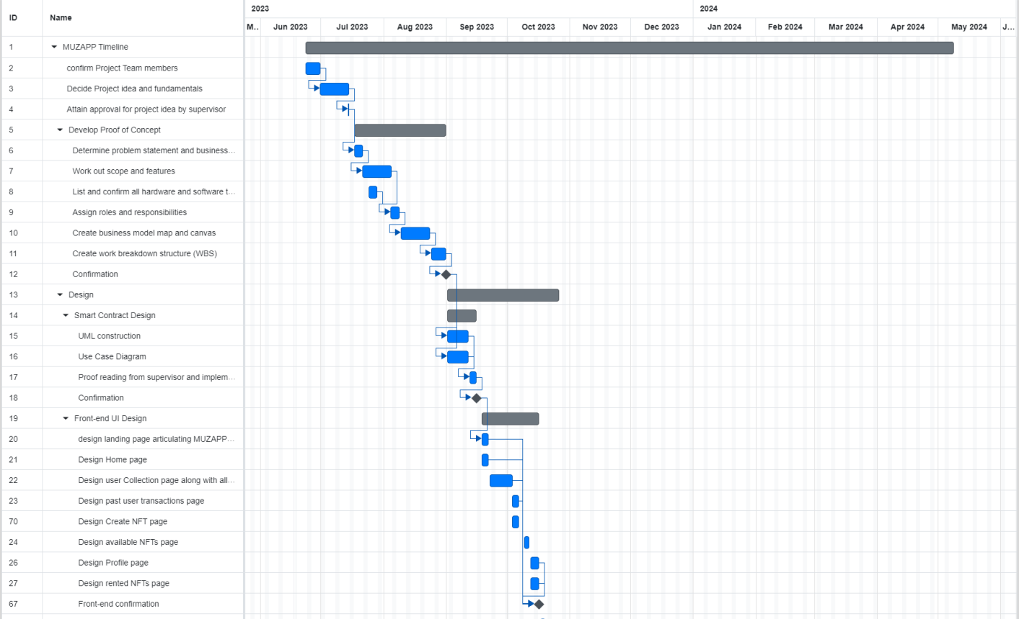

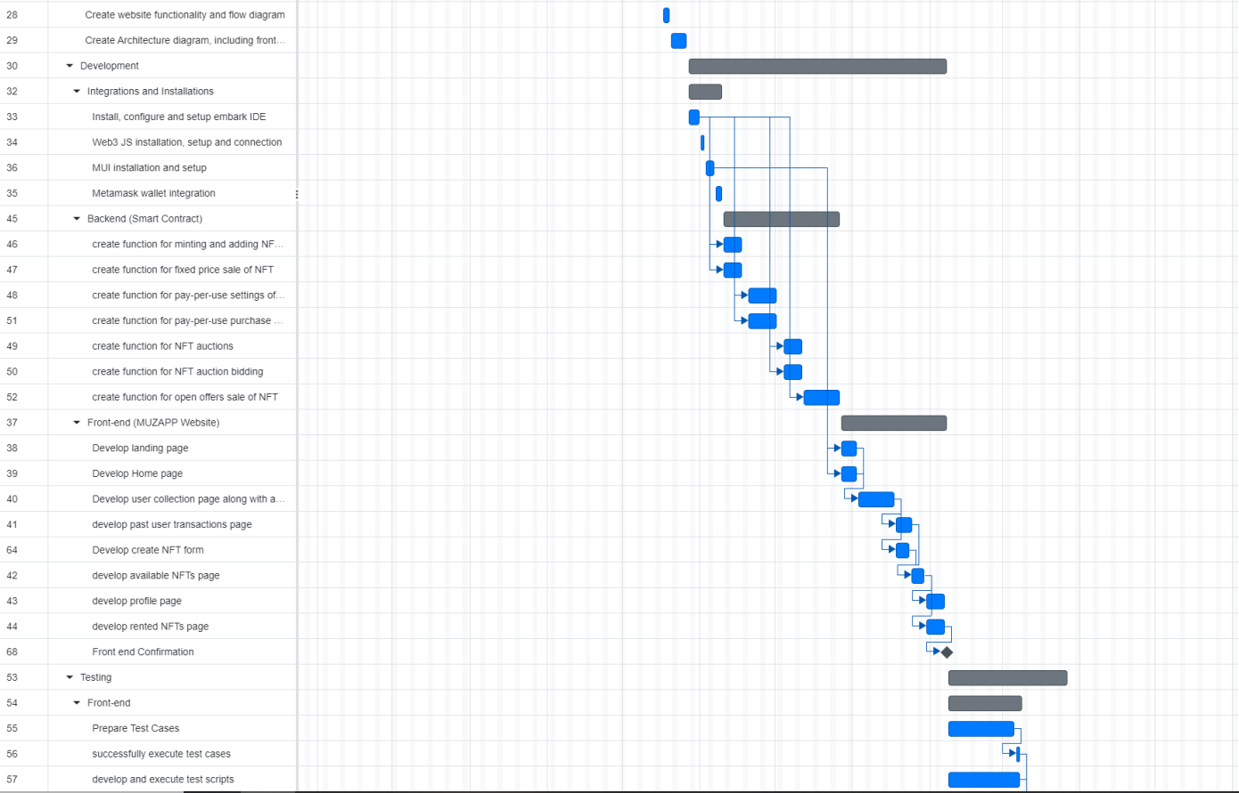

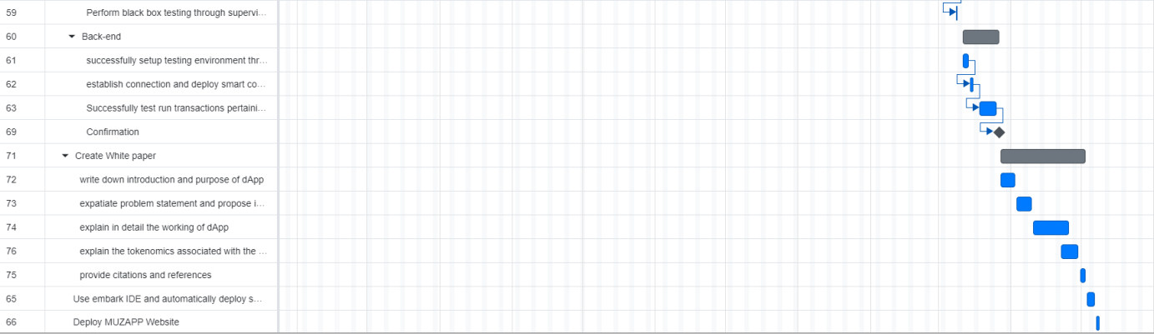

# **12. Work Breakdown Structure**

Semester I

|  |  |  |  |  |
| --- | --- | --- | --- | --- |
| **Level** | **WBS** | **Task Description** | **Timeline** | **Notes** |
| 1 | 1 | **Team and idea formation** |  |  |
| 2 | 1.1 | Confirm project team members | 23 June 2023 –  30 June 2023 |  |
| 2 | 1.2 | Decide project idea and fundamentals | 30 June 2023 – 14 July 2023 |  |
| 2 | 1.3 | Attain approval for project idea by supervisor | 14 July 2023 – 14 July 2023 |  |
| 1 | 2 | **POC Development** |  |  |
| 2 | 2.1 | Determine Problem Statement and business value | 17 July 2023 – 21 July 2023 |  |
| 2 | 2.2 | Work out scope and features | 21 July 2023 – 4 August 2023 |  |
| 2 | 2.3 | confirm all hardware and software tools | 24 July 2023 – 28 July 2023 |  |
| 2 | 2.4 | Assign roles and responsibilities | 4 August 2023 – 8 August 2023 |  |
| 2 | 2.5 | Create business model map and canvas | 9 August 2023 – 23 August 2023 |  |
| 2 | 2.6 | Create WBS | 24 August 2023 – 31 August 2023 |  |
| 1 | 3 | **Smart Contract Design** |  |  |
| 2 | 3.1 | UML Construction | 1 September 2023 – 11 September 2023 |  |
| 2 | 3.2 | Use Case Diagram | 1 September 2023 – 11 September 2023 |  |
| 2 | 3.3 | Supervisor Proof reading and Change implementation | 12 September 2023 – 15 September 2023 |  |
| 1 | 4 | **GUI and Architecture** |  |  |
| 2 | 4.1 | Landing Page | 18 September 2023 – 21 September 2023 |  |
| 2 | 4.2 | Home page | 18 September 2023 – 21 September 2023 |  |
| 2 | 4.3 | User Collection page with all associated forms | 22 September 2023 – 3 October 2023 |  |
| 2 | 4.4 | NFT Creation page | 3 October 2023 – 6 October 2023 |  |
| 2 | 4.5 | Available NFTs page | 9 October 2023 – 11 October 2023 |  |
| 2 | 4.6 | Profile page | 12 October 2023 – 16 October 2023 |  |
| 2 | 4.7 | Rented NFTs page | 12 October 2023 – 16 October 2023 |  |
| 2 | 4.8 | Web functionality and flow diagram | 17 October 2023 – 19 October 2023 |  |
| 2 | 4.9 | Full System Architecture including frontend, backend and database | 20 October 2023 – 26 October 2023 |  |

Semester II

|  |  |  |  |  |
| --- | --- | --- | --- | --- |
| **Level** | **WBS** | **Task Description** | **Timeline** | **Notes** |
| 1 | 1 | **Integrations and Installations** |  |  |
| 2 | 1.1 | Install, configure and setup embark IDE | 27 October 2023 – 31 October 2023 |  |
| 2 | 1.2 | Web3 JS installation, setup and connection | 1 November 2023 – 2 November 2023 |  |
| 2 | 1.3 | MUI installation and setup | 3 November 2023 – 6 November 2023 |  |
| 2 | 1.4 | Meta mask wallet integration | 7 November 2023 – 9 November 2023 |  |
| 1 | 2 | **Develop Smart Contract** |  |  |
| 2 | 2.1 | Create function for Minting and adding of NFTs | 10 November 2023 – 17 November 2023 |  |
| 2 | 2.2 | Create function for fixed price sale of NFTs | 10 November 2023 – 17 November 2023 |  |
| 2 | 2.3 | Create function for pay-per-use setting of NFTs | 20 November 2023 – 1 December 2023 |  |
| 2 | 2.4 | Create function for pay-per-use purchase | 20 November 2023 – 1 December 2023 |  |
| 2 | 2.5 | Create function for NFTs Auction | 4 December 2023 – 11 December 2023 |  |
| 2 | 2.6 | Create function for NFT auction bidding | 4 December 2023 – 11 December 2023 |  |
| 2 | 2.7 | Create function for open offer sale of NFT | 12 December 2013 – 26 December 2023 |  |
| 1 | 3 | **Website Creation** |  |  |
| 2 | 3.1 | Create landing page | 27 December 2023 – 2 January 2024 |  |
| 2 | 3.2 | Create home page | 27 December 2023 – 2 January 2024 |  |
| 2 | 3.3 | Create user collection page | 3 January 2024 – 17 January 2024 |  |
| 2 | 3.4 | Create past user transactions page | 18 January 2024 – 24 January 2024 |  |
| 2 | 3.5 | Create NFT creations page | 18 January 2024 – 23 January 2024 |  |
| 2 | 3.6 | Create available NFTs page | 24 January 2024 – 29 January 2024 |  |
| 2 | 3.7 | Create profile page | 30 January 2024 – 6 February 2024 |  |
| 2 | 3.8 | Create rented NFTs page | 30 January 2024 – 6 February 2024 |  |
| 1 | 4 | **Testing** |  |  |
| 2 | 4.1 | **Front-end** |  |  |
| 3 | 4.1.1 | Test case development | 8 February 2024 – 7 March 2024 |  |
| 3 | 4.1.2 | Test script development | 8 February 2024 – 7 March 2024 |  |
| 3 | 4.1.3 | Supervisor black box testing | 8 March 2024 - 8 March 2024 |  |
| 2 | 4.2 | **Back-end** |  |  |
| 3 | 4.2.1 | Ganache setup | 11 March 2024 – 13 March 2024 |  |
| 3 | 4.2.2 | Smart contract deployment to ganache environment | 14 March 2024 – 15 March 2024 |  |
| 3 | 4.2.3 | Test run transactions pertaining to all types of NFT purchase and sale | 18 March 2024 – 25 March 2024 |  |
| 1 | 5 | **White Paper Documentation** |  |  |
| 2 | 5.1 | write down introduction and purpose | 27 March 2024 – 2 April 2024 |  |
| 2 | 5.2 | Expatiate problem statement and proposed solution | 3 April 2024 – 9 April 2024 |  |
| 2 | 5.3 | Explain in detail the working of dApp | 10 April 2024 – 25 April 2024 |  |
| 2 | 5.4 | Describe tokenomics associated with dApp | 22 April 2024 – 29 April 2024 |  |
| 2 | 5.5 | Provide citations and references | 30 April 2024 – 2 May 2024 |  |

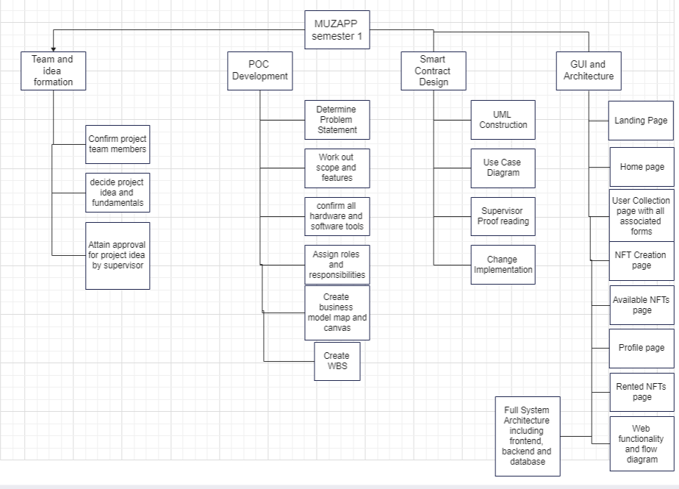

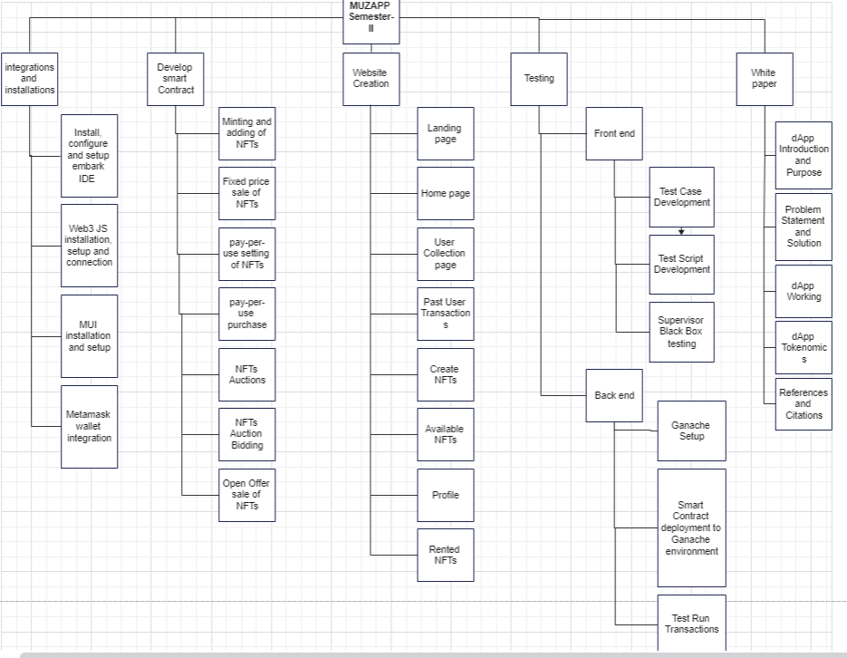

# **13. Business Model Map**

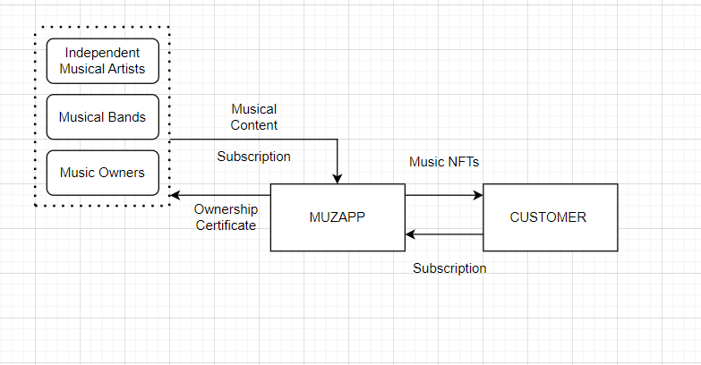

# **14. Business Model Canvas**

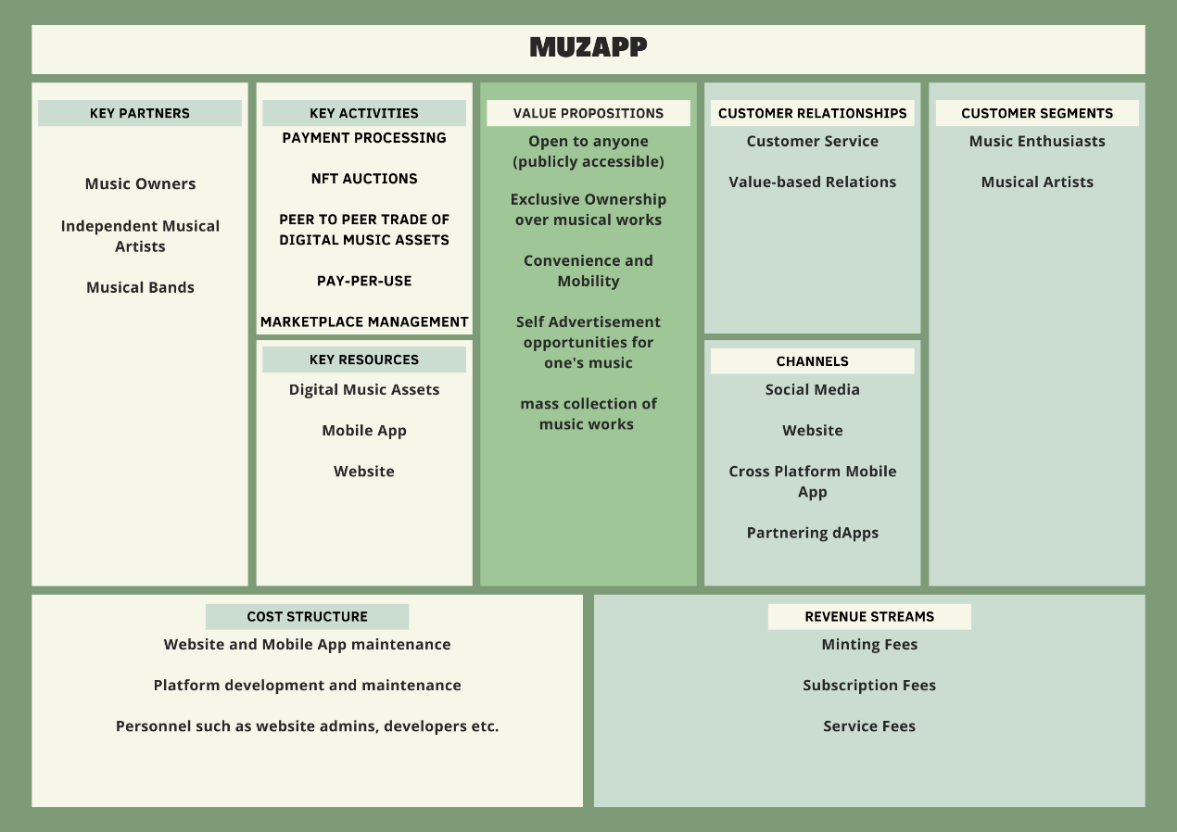

# **15. References**

# [Ani Karibian](https://mubert.com/blog/author/anikaribian) : “Challenges the Music Industry is Facing in the 21st Century”, January 17, 2022, June 24, 2023, [Challenges the Music Industry is Facing in the 21st Century | Mubert Blog — Mubert Blog](https://mubert.com/blog/challenges-the-music-industry-is-facing-in-the-21st-century)

Blockchain Evangelist, “choosing polygon over ethereum to build efficient dApps”, March 24, 2023, appinventiv, June 24, 2023, [Choosing Polygon over Ethereum to Build Efficient dApps (appinventiv.com)](https://appinventiv.com/blog/dapps-on-polygon/amp/)

Georgia Weston, “What is Ganache Blockchain – 101 Blockchains”, 5 August 2022, June 24, 2023, [What is Ganache Blockchain - 101 Blockchains](https://101blockchains.com/ganache-blockchain/)